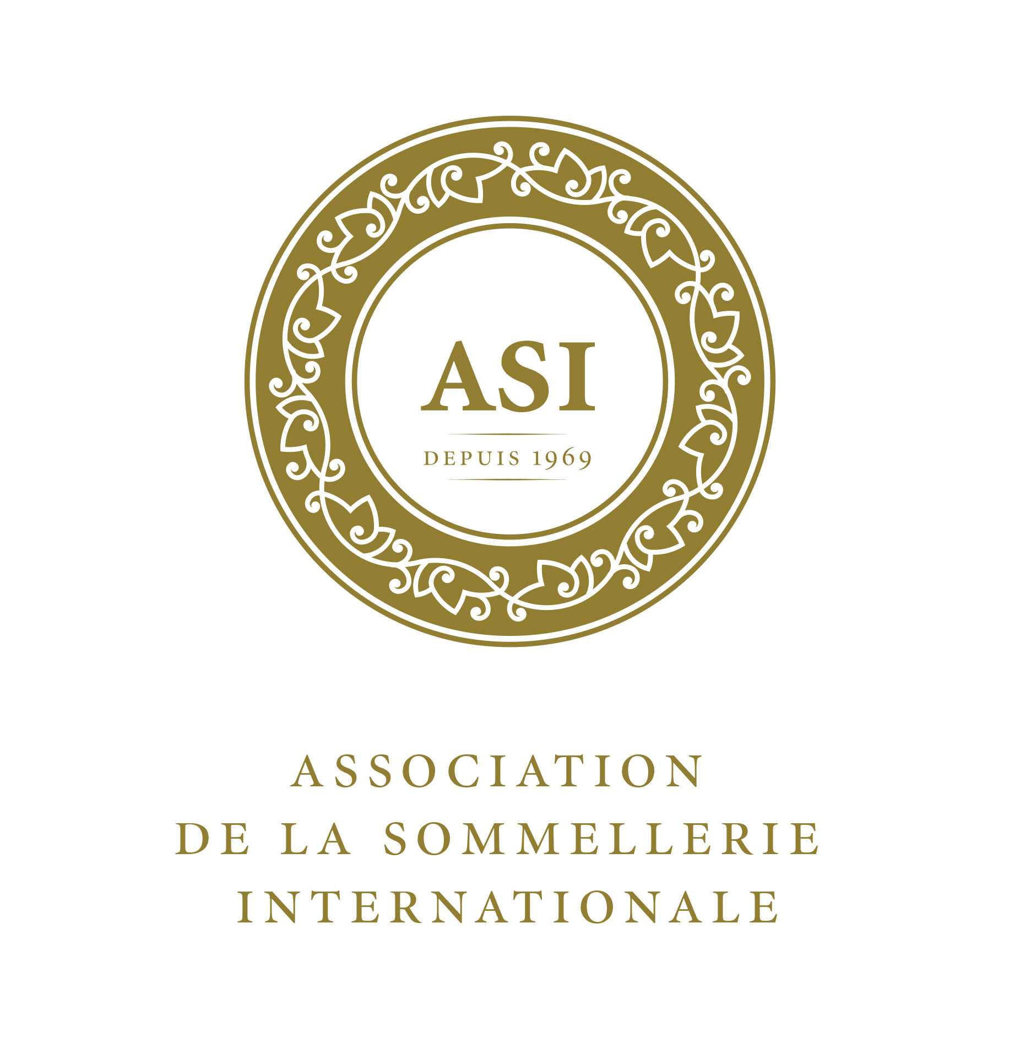

International ASI Diploma for Sommelier

2019 RULES / CANDIDATES

Art. 1 – Exam to obtain the Diploma
The ASI (Association de la Sommellerie Internationale www.asi.info) established, in 2012, the exam for “International ASI Diploma for Sommelier”, aiming to harmonize the level of sommeliers worldwide and prove in any part of the world the professionalism of the “Sommelier ASI”.

Art. 1 bis – From 2019, the “International ASI Diploma for Sommelier” is also open to candidates who prefer sitting for the exam in their own language, as far as it is one of the three official languages of ASI – French, English or Spanish – The Bronze level has been created for them. The outcome level for Bronze is the same as Silver or Gold levels Silver or Gold levels are only for sommeliers presenting all the tests in a foreign language.

Art. 2 – Rights to claim the exam
The exam is reserved to Sommeliers working within the oeno-gastronomy world (restaurants, wine-bars, wine shops, distribution, or other, who serves or recommends beverages on a professional level), who have at least 4 years of experience.

Art. 3 – Registration to the exam
The registration to the exam session must be made via the National Association ASI member that must send the following documents to diploma@asi.info

  - Application form filled out
  - Working and Studies CV (résumé) countersigned by his/her association
  - High resolution photo (passport style)

Art. 4 – Exam session
The session is held once per year and announced on the ASI website www.asi.info

Art. 5 – Local Exam Committee
The local Exam Committee is composed by sommeliers and oeno-gastronomy experts chosen and named by the President/Board of the National Association.

Art. 6 – Exams procedure
The exam takes place in two stages

1st stage - Written Tests:

  - Written description and identification of two wines served blind (20 minutes),
  - The identification of two local beverages and three spirits/liquors/fortified wines (10 minutes),
  - A questionnaire (90 minutes) focused on the main wine producing countries, beers, spirits and other beverages, grape varieties, viticulture, winemaking, and other topics related to the profession,
  - An essay (45 minutes) on a special theme provided by the ASI Exam Committee regarding the world of beverages and the sommellerie (500/800 words) in one of the three official languages of the ASI.

2nd stage – Oral and Practical tests:

  - Present, demonstrate and justify the choice of a beverage (4 minutes)
  - Decant, comment and serve a bottle of wine (6 minutes)
  - Taste and explain a food & wine matching (7 minutes)

Art. 7 – Official languages of the exam
The Candidate must take the exam in one of the Official ASI languages (French, English, Spanish). The candidate who wishes to use his/her own mother tongue, if it is French, English or Spanish for the whole exam can only achieve the Bronze level, as the Silver and Gold are reserved to the sommeliers who are fluent in a foreign language.

Art. 8 – Evaluation of the Exam
The ASI Exam Committee evaluates the written tests.
The local Exam Committee evaluates the oral and practical tests following the General Rules codified by ASI and its marking grids. All these papers are sent to the ASI Exam Committee for final evaluation. NB: the final evaluation is done according to a scale pre-set by the ASI Exam Committee.

Art. 9 – Exams results and communication to the candidate
The results are communicated to the President of the National Association who informs the successful candidates. Then the results are posted on the ASI website minimum five days after communicating to the National Associations.
  - In case of a failure, the candidate is allowed to sit again for the exam as many times as he/she wishes,
  - A candidate awarded the Bronze or Silver level, may sit again and try to obtain the Gold Diploma
Art. 10 – Diploma
The Candidate who successfully passes the exam receives the International ASI Sommelier Diploma numbered and signed by the ASI President and the President of the Exam Committee as well as the ASI pin and card.

Art. 11 – Transitional Rule: Diplomas to Sommelier already bearing certain awards
The Sommeliers of ASI Associations active members having already one of the following titles are de facto “ASI Sommelier”: Best Sommelier of the World, Best Sommelier of Europe, Best Sommelier of the Americas, Best Sommelier of Asia & Oceania.

Art. 12 – Transitional Rule: Sommelier ASI honoris causa
The ASI reserves its right to nominate “Sommelier ASI honoris causa” people who for years have worked to improve the Profession worldwide. Each National Association being an active paying member of the ASI may nominate one person per year to obtain the honoris causa diploma.

..................................................

